8050 Foam Kit Installation
Speaker Foam Assembly
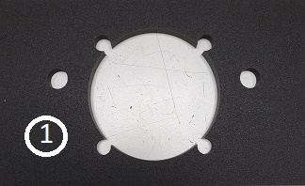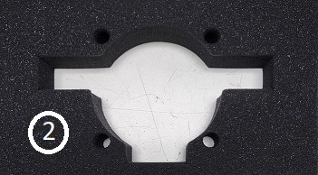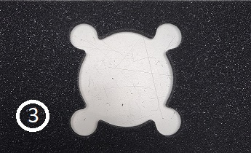
*NOTE – Some kits may come with these pieces already assembled as one piece.
- Gently pull speaker foam from the back of back of chamber and unplug.
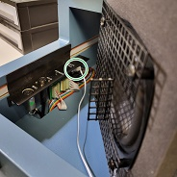

- Remove screen and standoff from old foam by removing 4 black screws Do not unscrew Silver screws on back side *NOTE – Standoffs are located under screen
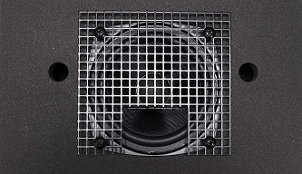
- Remove white rods from old foam and install in new foam pieces#1 and #2

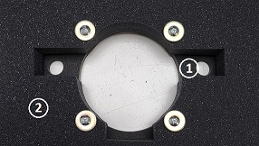

- Flip Foam pieces with rods over and feed speaker wire though opening and place body of the speaker and screen on the plastic rods as shown, with cutout/shelf on the bottom

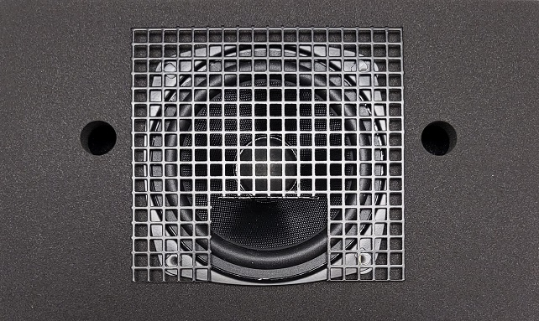

- Replace standoffs and black screws as shown.

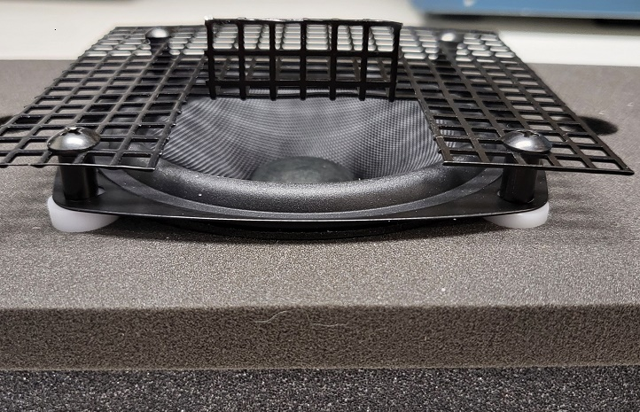

- Place Foam piece #3 against back wall of chamber.

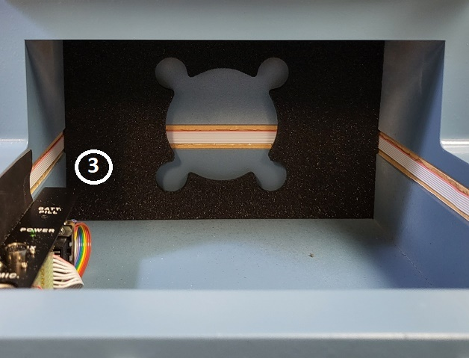

- Place speaker assembly in the back of the chamber against foam piece #3 with screen cutout/shelf on the bottom. Hook speaker back up.
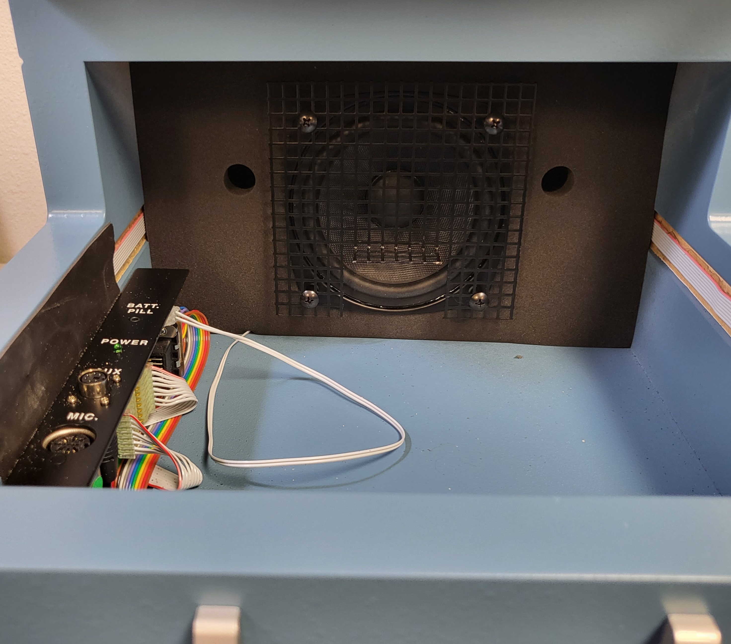

Lid Seal Kit

- Apply Lid seal kit to inside edge of chamber lid as shown in photo. Long place short strips on top and bottom of lip and long strips on edged.
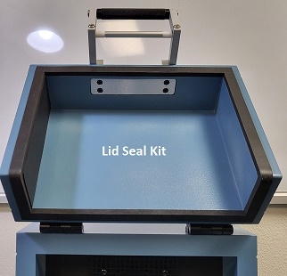
Chamber Foam
- Place part “A” in bottom of chamber screen cutout/shelf with wedge tips points facing speaker.
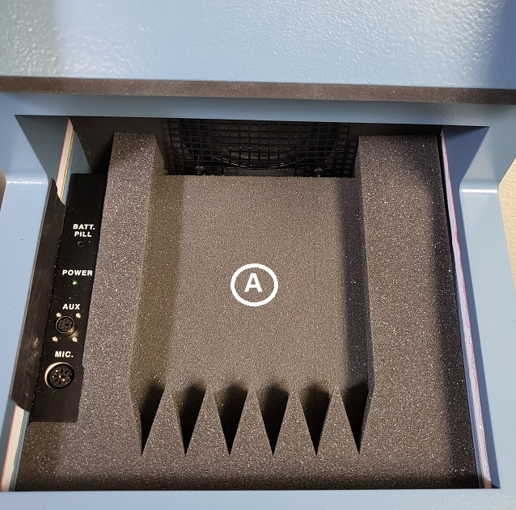

- Place part “B” on top of part “A” so it rests on screen cutout/shelf with wedge tips facing speakers.
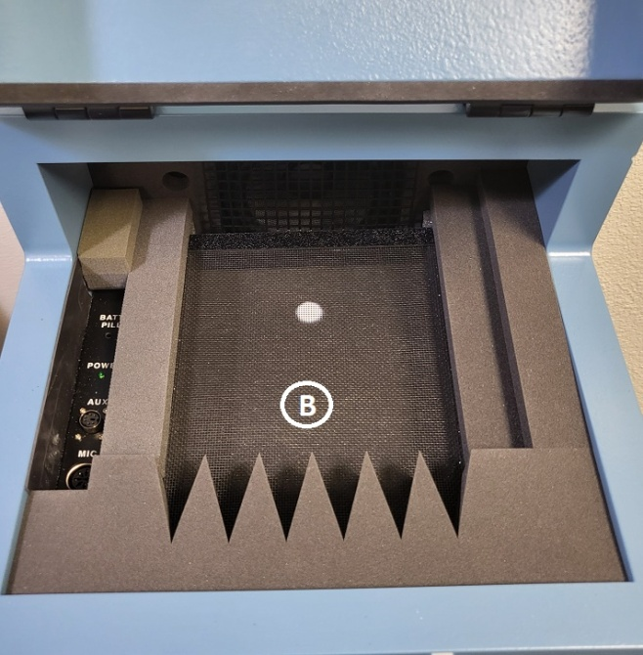

- Place “C” in back part of Chamber as shown. Make sure cut out is to the back.

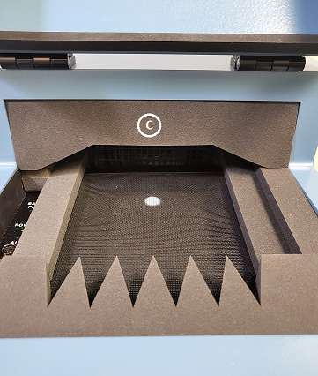

- Place “D” in chamber lid with wedge points pointing down

